CS 1120 – Computer Science II
Instructor: Dr. Yang, Western Michigan University
Lab TA: J.R. Doornbos

Marcel Englmaier&Thomas Ekema

SOFTWARE LIFE CYCLE REPORT – FOR LAB ASSIGNMENT 6

PHASE 1: SPECIFICATION (“What do we build?”)

Note that this is a pair-programming lab assignment.
Write a GUI application that works like a shopping cart system for a bookstore. For this application the input will be a binary inventory file where each record of the file is a triplet representing a book. The triplet is composed of:
• a boolean (true or false to represent an ebook or hardcopy, respectively)
• a String for the book title
• a double for the price

Note: See the lab website for instructions on downloading the binary file for this application.
GUI Specifications
Your window should:
• Allow the user to choose an inventory file through a file chooser dialog (see course textbook p. 821)
o The user clicks on the Choose File button.
o The file dialog window that allows to select directory and file shows up
o The user finds the proper directory
o The user selects a file by clicking on it
o The File name shows in the label
o If the user decides file chosen is not right, allow the user to choose a new inventory file.
CS 1120 Spring 2012 LA6 Book Shopping and Checkout

• By clicking the Load Inventory button, a user loads the contents of the binary Inventory file (to be named bookdata.dat ) into the Inventory list on the left. Your program should disable the Load Inventory and Choose Inventory button after the file is loaded into memory.
• After selecting a book from the inventory list, the user can add it to the Cart list by clicking the Add button. The user should also be able to remove a selection from the Cart list by clicking the Remove button.
• By clicking the Calculate Total button, a user can see the total amount in the Payment Due label. Your program should disable the Add button, the Remove button, and both lists after the Calculate Total button is pressed.
• Clicking the Checkout button should open a save file dialog window to create a text file; a receipt with the list of the purchased books, their prices, and the total amount

PHASE 2: DESIGN

2.1 Modules and Their Basic Structure
My program will have one module.
- Module 1: BookShopWindow will contain:
  - private fields for GUI components as well as variables needed for action listeners/methods
  - a constructor which creates a new java Jframe form
  - the main method which sets the look and feel of the GUI and instantiates a new BookShopWindow
  - a private void method buttonChooseFileActionPerformed which allows the user to select a file for reading
  - a private void method buttonLoadInventoryActionPerformed which calls the loadInventory method
  - a private void method addButtonActionPerformed which adds the selected item in a list to the user's “cart” list
  - a private void method removeButtonActionPerformed which removes the selected item from the user's “cart” list
  - a private void method calculateTotalButtonActionPerformed which calculates and displays the total cost of books in the user's cart
  - a private void method checkOutButtonActionPerformed which calls the printReceiptToText method
  - a private void method loadInventory which reads the selected file, formats it, and displays it as a list of books
  - a private void method printReceiptToText which prints a formatted text file “receipt” to the location previously specified by the user

  - Pseudocode for the Modules

    - Pseudocode for BookShopWindow (final refinement):

/*
* BookShopWindow.java
*
* Created on Mar 23, 2012, 9:49:27 PM
*/

/**
* Class BookShopWindow
* @author thomas/marcel
*/

//various variables which allow functionality/are critical to use

/** Create new form BookShopWindow */

/** This method is called from within the constructor to
* initialize the form.
* WARNING: Do NOT modify this code. The content of this method is
* always regenerated by the Form Editor.
*/

/**
* code generated by java GUI creater
*/

/**
* This method responds to a mouse click on the "choose file" button
* @param evt Takes in a action event (in this case, a mouse click) as the parameter
*/

//displays a Java File Chooser for user to select input file
//instantiates a file object from the chosen file
//read and display the file name and path in a label

/**
* This method responds to a mouse click on the "load inventory" button
* @param evt Takes in a action event (in this case, a mouse click) as the parameter
*/

//private void method buttonLoadInventoryActionPerformed
//try/catch block to call loadInventory method, catching nullPointerException and IOException
//try calling loadInventory
//catch nullPointerException, display “No File is chosen, please choose a file”
//catch IOException, display “There was a File-Read error, please check file”

/**
* This method responds to a mouse click on the "add" button
* @param evt Takes in a action event (in this case, a mouse click) as the parameter
*/

//private void method addButtonActionPerformed
//add selected value to the ArrayList object
//create a new string array of the same size
//for i equals 0 to i is less than the length of the string array, do:
//fill the string array with the contents of the ArrayList object
//set list data to display the string array
//if there are items in the cart, enable the calculate button
//else disable the calculate button

/**
* This method responds to a mouse click on the "remove" button
* @param evt Takes in a action event (in this case, a mouse click) as the parameter
*/

//private void removeButtonActionPerformed
//Remove selected value from ArrayList object
//create a new string array of the same size
//for i equals 0 to i is less than the length of the string array, do:
//fill the string array with the contents of the ArrayList object
//set the list data to display the string array
//if there are items in the cart, enable the calculate button
//else disable the calculate button

/**
* This method responds to a mouse click on the "calculate" button
* @param evt Takes in a action event (in this case, a mouse click) as the parameter
*/

//private void method calculateTotalButtonActionPerformed
//for i equals 0 to i is less than the ArrayList object size, do:
//add the doubles found at the end of the string to a temporary double
//set total cost equal to the temporary double and display in label
//enable/disable proper buttons

/**
* This method responds to a mouse click on the "check out" button
* @param evt Takes in a action event (in this case, a mouse click) as the parameter
*/

//private void method checkOutButtonActionPerformed
//try/catch block to call printReceiptToText method, catching any IOException
//try calling printReceiptToText
//catch IOException, display "Checkout Error"

/**
* Main method
* @param args the command line arguments
*/

/* Set the Nimbus look and feel (from java GUI creater)*/
/* Create and display the form (from java GUI creater)*/

/**
* This method reads the .dat file, and outputs the values to three arrays
*/

//private void method loadInventory
//loads user's input file to raf
//declare and initialize variables needed for reading algorithm
//three arrays are used as the trade-off manipulation arrays that allow the reading algorithm to function
//a loop to repeat so long as information exists. Do:
//try-catch block in loop repeats until an error is caught, and then the loop discontinues
//try:
//assigning variable and resetting main variables before reading
//reading file
//assigning read information to appropriate variables
//assigning variables and reseting temp variable
//catch IOException, set doLoopAgain boolean to false

//while doLoopAgain is true

//format final variable through temp variable
//add listString array to list
//disable load inventory file and check filename
//enable GUI for use

/**
* This method takes information from the GUI, and prints the information in the
* -form of a receipt to the any user's desktop
*/

//private void method printReceiptToText
//use JfileChooser to create file path to user's chosed folder, and create a receipt.txt file there
//other declarations/initiations
//print header
//write list of items in cart to receipt
//write cost to file, subtotal, sales tax, and total, then show receipt print success message
//clear and enable/disable all components of gui

// Variables declaration - do not modify

PHASE 3: RISK ANALYSIS (“What can go wrong, and how bad can it be?”)

No risks (to timetable, cost, human health, etc.) are identified by me.

PHASE 4: VERIFICATION (“Are the algorithms correct?”)

The algorithm has multiple execution path (a branching execution). Correctness of the path has been verified by me by analyzing its steps, and their completeness w.r.t. the Specification.

PHASE 5: CODING

5c) Final Code Refinement (complete program--with complete fields, code for constructor/methods)

/*
* BookShopWindow.java
*
* Created on Mar 23, 2012, 9:49:27 PM
*/
package booksGroupProject;

import java.io.*;
import java.text.DecimalFormat;
import java.util.ArrayList;
import java.util.GregorianCalendar;
import javax.swing.JFileChooser;
import javax.swing.JOptionPane;

/**
*
* @author thomas/marcel
*/
public class BookShopWindow extends javax.swing.JFrame {
//various methods which allow functionality/are critical to use
private File selectedFile;
private File saveFile;
private boolean [] inputBoolean = new boolean[1];
private String saveFilePath;
private String [] inputString = new String[1];
private double [] inputDouble = new double [1];
private ArrayList<String> cartItems = new ArrayList<String>();
private String [] cartItemsStringArray;
private DecimalFormat formatMyDouble = new DecimalFormat("0.00");
//when checkout is pressed, create these with number of items
private double totalCost;

/** Creates new form BookShopWindow */
public BookShopWindow() {
initComponents();
}

/** This method is called from within the constructor to
* initialize the form.
* WARNING: Do NOT modify this code. The content of this method is
* always regenerated by the Form Editor.
*/
@SuppressWarnings("unchecked")
// <editor-fold defaultstate="collapsed" desc="Generated Code">
private void initComponents() {

jSeparator3 = new javax.swing.JSeparator();
greetingLabel = new javax.swing.JLabel();
jSeparator1 = new javax.swing.JSeparator();
buttonChooseFile = new javax.swing.JButton();
buttonLoadInventory = new javax.swing.JButton();
fieldFileName = new javax.swing.JLabel();
jSeparator2 = new javax.swing.JSeparator();
jScrollPane1 = new javax.swing.JScrollPane();
inventoryList = new javax.swing.JList();
jScrollPane2 = new javax.swing.JScrollPane();
cartList = new javax.swing.JList();
addButton = new javax.swing.JButton();
removeButton = new javax.swing.JButton();
jSeparator4 = new javax.swing.JSeparator();
calculateTotalButton = new javax.swing.JButton();
paymentDueLabel = new javax.swing.JLabel();
checkOutButton = new javax.swing.JButton();

setDefaultCloseOperation(javax.swing.WindowConstants.EXIT_ON_CLOSE);

greetingLabel.setText("Welcome to the Book Shop");

buttonChooseFile.setText("Choose File");
buttonChooseFile.addActionListener(new java.awt.event.ActionListener() {
public void actionPerformed(java.awt.event.ActionEvent evt) {
buttonChooseFileActionPerformed(evt);
}
});

buttonLoadInventory.setText("Load Inventory");
buttonLoadInventory.addActionListener(new java.awt.event.ActionListener() {
public void actionPerformed(java.awt.event.ActionEvent evt) {
buttonLoadInventoryActionPerformed(evt);
}
});

jScrollPane1.setViewportView(inventoryList);

jScrollPane2.setViewportView(cartList);

addButton.setText("Add-->");
addButton.addActionListener(new java.awt.event.ActionListener() {
public void actionPerformed(java.awt.event.ActionEvent evt) {
addButtonActionPerformed(evt);
}
});

removeButton.setText("Remove");
removeButton.addActionListener(new java.awt.event.ActionListener() {
public void actionPerformed(java.awt.event.ActionEvent evt) {
removeButtonActionPerformed(evt);
}
});

calculateTotalButton.setText("Calculate Total");
calculateTotalButton.addActionListener(new java.awt.event.ActionListener() {
public void actionPerformed(java.awt.event.ActionEvent evt) {
calculateTotalButtonActionPerformed(evt);
}
});

checkOutButton.setText("Checkout!");
checkOutButton.addActionListener(new java.awt.event.ActionListener() {
public void actionPerformed(java.awt.event.ActionEvent evt) {
checkOutButtonActionPerformed(evt);
}
});

javax.swing.GroupLayout layout = new javax.swing.GroupLayout(getContentPane());
getContentPane().setLayout(layout);
layout.setHorizontalGroup(
layout.createParallelGroup(javax.swing.GroupLayout.Alignment.LEADING)
.addComponent(jSeparator2, javax.swing.GroupLayout.DEFAULT_SIZE, 727, Short.MAX_VALUE)
.addComponent(jSeparator1, javax.swing.GroupLayout.DEFAULT_SIZE, 727, Short.MAX_VALUE)
.addGroup(layout.createSequentialGroup()
.addContainerGap()
.addGroup(layout.createParallelGroup(javax.swing.GroupLayout.Alignment.LEADING)
.addGroup(layout.createSequentialGroup()
.addComponent(jScrollPane1, javax.swing.GroupLayout.PREFERRED_SIZE, 298, javax.swing.GroupLayout.PREFERRED_SIZE)
.addGap(18, 18, 18)
.addGroup(layout.createParallelGroup(javax.swing.GroupLayout.Alignment.TRAILING)
.addGroup(layout.createSequentialGroup()
.addComponent(addButton)
.addGap(3, 3, 3))
.addComponent(removeButton))
.addGap(18, 18, 18)
.addComponent(jScrollPane2, javax.swing.GroupLayout.DEFAULT_SIZE, 280, Short.MAX_VALUE))
.addGroup(layout.createSequentialGroup()
.addGroup(layout.createParallelGroup(javax.swing.GroupLayout.Alignment.TRAILING, false)
.addComponent(buttonChooseFile, javax.swing.GroupLayout.Alignment.LEADING, javax.swing.GroupLayout.DEFAULT_SIZE, javax.swing.GroupLayout.DEFAULT_SIZE, Short.MAX_VALUE)
.addComponent(buttonLoadInventory, javax.swing.GroupLayout.Alignment.LEADING, javax.swing.GroupLayout.DEFAULT_SIZE, javax.swing.GroupLayout.DEFAULT_SIZE, Short.MAX_VALUE))
.addGap(50, 50, 50)
.addComponent(fieldFileName)))
.addContainerGap())
.addGroup(javax.swing.GroupLayout.Alignment.TRAILING, layout.createSequentialGroup()
.addContainerGap(278, Short.MAX_VALUE)
.addComponent(greetingLabel)
.addGap(259, 259, 259))
.addComponent(jSeparator4, javax.swing.GroupLayout.DEFAULT_SIZE, 727, Short.MAX_VALUE)
.addGroup(layout.createSequentialGroup()
.addGap(211, 211, 211)
.addGroup(layout.createParallelGroup(javax.swing.GroupLayout.Alignment.LEADING)
.addGroup(layout.createSequentialGroup()
.addComponent(calculateTotalButton)
.addGap(70, 70, 70)
.addComponent(paymentDueLabel))
.addGroup(layout.createSequentialGroup()
.addGap(118, 118, 118)
.addComponent(checkOutButton)))
.addContainerGap(293, Short.MAX_VALUE))
);
layout.setVerticalGroup(
layout.createParallelGroup(javax.swing.GroupLayout.Alignment.LEADING)
.addGroup(layout.createSequentialGroup()
.addContainerGap()
.addComponent(greetingLabel)
.addPreferredGap(javax.swing.LayoutStyle.ComponentPlacement.RELATED)
.addComponent(jSeparator1, javax.swing.GroupLayout.PREFERRED_SIZE, 10, javax.swing.GroupLayout.PREFERRED_SIZE)
.addPreferredGap(javax.swing.LayoutStyle.ComponentPlacement.RELATED)
.addGroup(layout.createParallelGroup(javax.swing.GroupLayout.Alignment.BASELINE)
.addComponent(buttonChooseFile)
.addComponent(fieldFileName))
.addPreferredGap(javax.swing.LayoutStyle.ComponentPlacement.UNRELATED)
.addComponent(buttonLoadInventory)
.addPreferredGap(javax.swing.LayoutStyle.ComponentPlacement.UNRELATED)
.addComponent(jSeparator2, javax.swing.GroupLayout.PREFERRED_SIZE, 14, javax.swing.GroupLayout.PREFERRED_SIZE)
.addGroup(layout.createParallelGroup(javax.swing.GroupLayout.Alignment.LEADING)
.addGroup(layout.createSequentialGroup()
.addGap(57, 57, 57)
.addComponent(addButton)
.addGap(18, 18, 18)
.addComponent(removeButton)
.addGap(67, 67, 67))
.addGroup(layout.createSequentialGroup()
.addPreferredGap(javax.swing.LayoutStyle.ComponentPlacement.RELATED)
.addGroup(layout.createParallelGroup(javax.swing.GroupLayout.Alignment.TRAILING)
.addComponent(jScrollPane2, javax.swing.GroupLayout.Alignment.LEADING, javax.swing.GroupLayout.DEFAULT_SIZE, 186, Short.MAX_VALUE)
.addComponent(jScrollPane1, javax.swing.GroupLayout.Alignment.LEADING, javax.swing.GroupLayout.DEFAULT_SIZE, 186, Short.MAX_VALUE))))
.addPreferredGap(javax.swing.LayoutStyle.ComponentPlacement.UNRELATED)
.addComponent(jSeparator4, javax.swing.GroupLayout.PREFERRED_SIZE, 12, javax.swing.GroupLayout.PREFERRED_SIZE)
.addPreferredGap(javax.swing.LayoutStyle.ComponentPlacement.RELATED)
.addGroup(layout.createParallelGroup(javax.swing.GroupLayout.Alignment.BASELINE)
.addComponent(calculateTotalButton)
.addComponent(paymentDueLabel))
.addPreferredGap(javax.swing.LayoutStyle.ComponentPlacement.UNRELATED)
.addComponent(checkOutButton)
.addContainerGap())
);

addButton.setEnabled(false);
removeButton.setEnabled(false);
calculateTotalButton.setEnabled(false);
checkOutButton.setEnabled(false);

pack();
}// </editor-fold>
/**
* This method responds to a mouse click on the "choose file" button
* @param evt Takes in a action event (in this case, a mouse click) as the parameter
*/
private void buttonChooseFileActionPerformed(java.awt.event.ActionEvent evt) {
//displays a Java File Chooser for user to select input file
JFileChooser fileChooser = new JFileChooser();
int status = fileChooser.showOpenDialog(null);
if(status == JFileChooser.APPROVE_OPTION)
{
//instantiates a file object from the chosen file
selectedFile = fileChooser.getSelectedFile();
//read and display the file name and path in a label
String bookdata = selectedFile.getPath();
fieldFileName.setText(bookdata);
}
}
/**
* This method responds to a mouse click on the "load inventory" button
* @param evt Takes in a action event (in this case, a mouse click) as the parameter
*/
private void buttonLoadInventoryActionPerformed(java.awt.event.ActionEvent evt) {
//load inventory, and depending on how file is treated, display appropriate errors
try
{
loadInventory();
}
catch(NullPointerException e)
{
JOptionPane.showMessageDialog(null, "No File is chosen, please choose a file", "Error", JOptionPane.ERROR_MESSAGE);
}
catch(IOException e)
{
JOptionPane.showMessageDialog(null, "There was a File-Read error, please check file", "Error", JOptionPane.ERROR_MESSAGE);
}
}
/**
* This method responds to a mouse click on the "add" button
* @param evt Takes in a action event (in this case, a mouse click) as the parameter
*/
private void addButtonActionPerformed(java.awt.event.ActionEvent evt) {
//add selected value to the ArrayList object
cartItems.add((String)inventoryList.getSelectedValue());
//create a new string array of the same size
cartItemsStringArray = new String[cartItems.size()];
int i;
//for i equals 0 to i is less than the length of the string array, do:
for(i = 0; i < cartItemsStringArray.length; i++)
{
//fill the string array with the contents of the ArrayList object
cartItemsStringArray[i] = cartItems.get(i);
}
//set list data to display the string array
cartList.setListData(cartItemsStringArray);
//check for contents of cart, and allow GUI components depending on cart
if(cartItems.size() > 0)
{
calculateTotalButton.setEnabled(true);
}
else
{
calculateTotalButton.setEnabled(false);
}
}
/**
* This method responds to a mouse click on the "remove" button
* @param evt Takes in a action event (in this case, a mouse click) as the parameter
*/
private void removeButtonActionPerformed(java.awt.event.ActionEvent evt) {
//Remove selected value from ArrayList object
cartItems.remove(cartList.getSelectedIndex());
//create a new string array of the same size
cartItemsStringArray = new String[cartItems.size()];
int i;
//for i equals 0 to i is less than the length of the string array, do:
for(i = 0; i < cartItemsStringArray.length; i++)
{
//fill the string array with the contents of the ArrayList object
cartItemsStringArray[i] = cartItems.get(i);
}
//set the list data to display the string array
cartList.setListData(cartItemsStringArray);
//check for contents of cart, and allow GUI components depending on cart
if(cartItems.size() > 0)
{
calculateTotalButton.setEnabled(true);
}
else
{
calculateTotalButton.setEnabled(false);
}
}
/**
* This method responds to a mouse click on the "calculate" button
* @param evt Takes in a action event (in this case, a mouse click) as the parameter
*/
private void calculateTotalButtonActionPerformed(java.awt.event.ActionEvent evt) {
//add the total of the doubles, format to price
int i;
double temp = 0;
//for i equals 0 to i is less than the ArrayList object size, do:
for(i = 0; i < cartItems.size(); i++)
{
//add the doubles found at the end of the string to a temporary double
temp += Double.parseDouble(cartItems.get(i).substring(cartItems.get(i).length() - 5, cartItems.get(i).length()));
}
//set total cost equal to the temporary double and display in label
totalCost = temp;
paymentDueLabel.setText(formatMyDouble.format(totalCost) + "");
//enable/disable proper buttons
addButton.setEnabled(false);
removeButton.setEnabled(false);
checkOutButton.setEnabled(true);
calculateTotalButton.setEnabled(false);
}
/**
* This method responds to a mouse click on the "check out" button
* @param evt Takes in a action event (in this case, a mouse click) as the parameter
*/
private void checkOutButtonActionPerformed(java.awt.event.ActionEvent evt) {
//try/catch block to call printReceiptToText method, catching any IOException
try
{
printReceiptToText();
}
catch(IOException e)
{
JOptionPane.showMessageDialog(null, "Checkout Error", "Error", JOptionPane.ERROR_MESSAGE);
}
}

/**
* @param args the command line arguments
*/
public static void main(String args[]) {
/* Set the Nimbus look and feel */
//<editor-fold defaultstate="collapsed" desc=" Look and feel setting code (optional) ">
/* If Nimbus (introduced in Java SE 6) is not available, stay with the default look and feel.
* For details see http://download.oracle.com/javase/tutorial/uiswing/lookandfeel/plaf.html
*/
try {
for (javax.swing.UIManager.LookAndFeelInfo info : javax.swing.UIManager.getInstalledLookAndFeels()) {
if ("Nimbus".equals(info.getName())) {
javax.swing.UIManager.setLookAndFeel(info.getClassName());
break;
}
}
} catch (ClassNotFoundException ex) {
java.util.logging.Logger.getLogger(BookShopWindow.class.getName()).log(java.util.logging.Level.SEVERE, null, ex);
} catch (InstantiationException ex) {
java.util.logging.Logger.getLogger(BookShopWindow.class.getName()).log(java.util.logging.Level.SEVERE, null, ex);
} catch (IllegalAccessException ex) {
java.util.logging.Logger.getLogger(BookShopWindow.class.getName()).log(java.util.logging.Level.SEVERE, null, ex);
} catch (javax.swing.UnsupportedLookAndFeelException ex) {
java.util.logging.Logger.getLogger(BookShopWindow.class.getName()).log(java.util.logging.Level.SEVERE, null, ex);
}
//</editor-fold>

/* Create and display the form */
java.awt.EventQueue.invokeLater(new Runnable() {

@Override
public void run() {
new BookShopWindow().setVisible(true);
}
});
}

/**
* This method reads the .dat file, and outputs the values to three arrays
*/
private void loadInventory() throws IOException
{
//loads user's input file to raf
RandomAccessFile raf = new RandomAccessFile(selectedFile, "rw");
//declare and initialize variables needed for reading algorithm
int i = 0;
boolean doLoopAgain = true;
boolean readingBoolean = true;
String readingString = "";
String[] listString;
double readingDouble = 1.0;
//these three arrays are the trade-off manipulation arrays that allow the reading algorithm to function
boolean [] manipulationBoolean = new boolean[1];
String [] manipulationString = new String[1];
double [] manipulationDouble = new double[1];

//a loop to repeat so long as information exists
do
{
//try-catch block in loop repeats until an error is caught, and then the loop discontinues
try
{
//<editor-fold defaultstate="collapsed" desc="assigning variable and resetting main variables before reading">
for(i = 0; i < manipulationBoolean.length - 1; i++)
{
manipulationBoolean[i] = inputBoolean[i];
}
inputBoolean = new boolean[manipulationBoolean.length];

for(i = 0; i < manipulationString.length - 1; i++)
{
manipulationString[i] = inputString[i];
}
inputString = new String[manipulationString.length];

for(i = 0; i < manipulationDouble.length - 1; i++)
{
manipulationDouble[i] = inputDouble[i];
}
inputDouble = new double[manipulationDouble.length];
//</editor-fold>

//reading file
readingBoolean = raf.readBoolean();
readingString = raf.readUTF();
readingDouble = raf.readDouble();

//assigning read information to appropriate variables
manipulationBoolean[manipulationBoolean.length - 1] = readingBoolean;
manipulationString[manipulationString.length - 1] = readingString;
manipulationDouble[manipulationDouble.length - 1] = readingDouble;

//<editor-fold defaultstate="collapsed" desc="assigning variables and reseting temp variable">
for(i = 0; i < manipulationDouble.length; i++)
{
inputDouble[i] = manipulationDouble[i];
}
manipulationDouble = new double[inputDouble.length + 1];

for(i = 0; i < manipulationString.length; i++)
{
inputString[i] = manipulationString[i];
}
manipulationString = new String[inputString.length + 1];

for(i = 0; i < manipulationBoolean.length; i++)
{
inputBoolean[i] = manipulationBoolean[i];
}
manipulationBoolean = new boolean[inputBoolean.length + 1];
//</editor-fold>
}
catch(IOException e)
{
doLoopAgain = false;
}

}while(doLoopAgain);

//<editor-fold defaultstate="collapsed" desc="fomatting final variable through temp variable">
inputBoolean = new boolean[manipulationBoolean.length - 1];
inputString = new String[manipulationString.length - 1];
inputDouble = new double[manipulationDouble.length - 1];
listString = new String[manipulationString.length - 1];
for(i = 0; i < inputBoolean.length; i++)
{
inputBoolean[i] = manipulationBoolean[i];
inputString[i] = manipulationString[i];
inputDouble[i] = manipulationDouble[i];
if(inputBoolean[i])
listString[i] = "ebook --> " + inputString[i] + formatMyDouble.format(inputDouble[i]);
else
listString[i] = "hardcopy --> " + inputString[i] + formatMyDouble.format(inputDouble[i]);
}
//</editor-fold>

//add listString array to list
inventoryList.setListData(listString);
//disable load inventory file and check filename
buttonLoadInventory.setEnabled(false);
buttonChooseFile.setEnabled(false);

//enable GUI for use
addButton.setEnabled(true);
removeButton.setEnabled(true);
calculateTotalButton.setEnabled(true);
}

/**
* This method takes information from the GUI, and prints the information in the
* -form of a receipt to the any user's desktop
*/
private void printReceiptToText() throws IOException
{
JFileChooser fileSave = new JFileChooser();
int status = fileSave.showOpenDialog(null);
if(status == JFileChooser.APPROVE_OPTION)
{
saveFile = fileSave.getSelectedFile();
String saveFilePath = saveFile.getPath();

//create file path to user's desktop, and create a receipt.txt file there
//String userHomeFolder = System.getProperty("user.home") + "\\Desktop";

File receiptFile = new File(saveFilePath);
receiptFile.createNewFile();
PrintWriter writeFile = new PrintWriter(receiptFile);
//other declarations/initiations
int i = 0;
GregorianCalendar timeStamp = new GregorianCalendar();

//print header
writeFile.println("-----------------The Book Shop-----------------");
writeFile.println("--------------Kalamazoo, Mi, 49024--------------");
writeFile.println("");
writeFile.println("Bought Through: The Book Shop Official App");
writeFile.println("");
writeFile.println(timeStamp.getTime());
writeFile.println("");
writeFile.println("------------------------------------------------");
writeFile.println("");
//write list of items in cart to receipt
for(i = 0; i < cartItems.size(); i++)
writeFile.println(cartItems.get(i));

//write cost to file, subtotal, sales tax, and total, then show receipt print success message
writeFile.println("");
writeFile.println("------------------------------------------------");
writeFile.println("");
writeFile.print("Subtotal: ");
writeFile.println(formatMyDouble.format(totalCost));
writeFile.print("Sales Tax: ");
double salesTax = totalCost * .06;
writeFile.println(formatMyDouble.format(salesTax));
totalCost = totalCost + salesTax;
writeFile.print("Total Cost: ");
writeFile.println(formatMyDouble.format(totalCost));
JOptionPane.showMessageDialog(null, "Receipt printed Successfully", "Success", JOptionPane.INFORMATION_MESSAGE);
writeFile.close();

//clear and enable all components of gui
String [] clear = {""};
buttonChooseFile.setEnabled(true);
buttonLoadInventory.setEnabled(true);
addButton.setEnabled(true);
removeButton.setEnabled(true);
calculateTotalButton.setEnabled(true);
checkOutButton.setEnabled(true);
fieldFileName.setText("");
paymentDueLabel.setText("");
inventoryList.setListData(clear);
cartList.setListData(clear);
}
}

// Variables declaration - do not modify
private javax.swing.JButton addButton;
private javax.swing.JButton buttonChooseFile;
private javax.swing.JButton buttonLoadInventory;
private javax.swing.JButton calculateTotalButton;
private javax.swing.JList cartList;
private javax.swing.JButton checkOutButton;
private javax.swing.JLabel fieldFileName;
private javax.swing.JLabel greetingLabel;
private javax.swing.JList inventoryList;
private javax.swing.JScrollPane jScrollPane1;
private javax.swing.JScrollPane jScrollPane2;
private javax.swing.JSeparator jSeparator1;
private javax.swing.JSeparator jSeparator2;
private javax.swing.JSeparator jSeparator3;
private javax.swing.JSeparator jSeparator4;
private javax.swing.JLabel paymentDueLabel;
private javax.swing.JButton removeButton;
// End of variables declaration
}

PHASE 6: TESTING (“Did we build it correctly?”)

This program has many execution paths. Therefore multiple runs test it completely.

Testing produces the following output of the program:
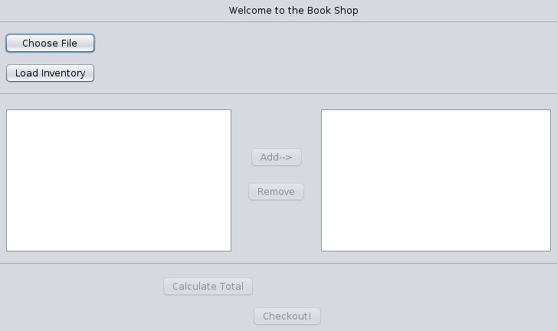

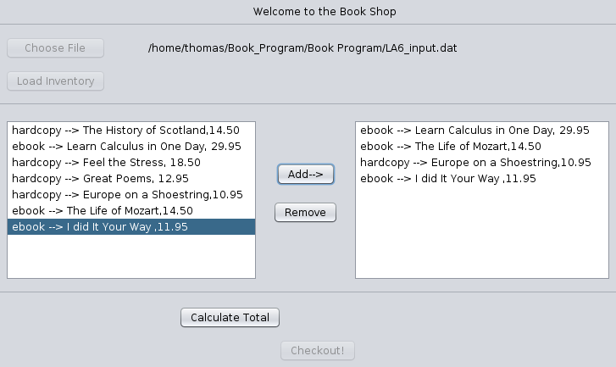
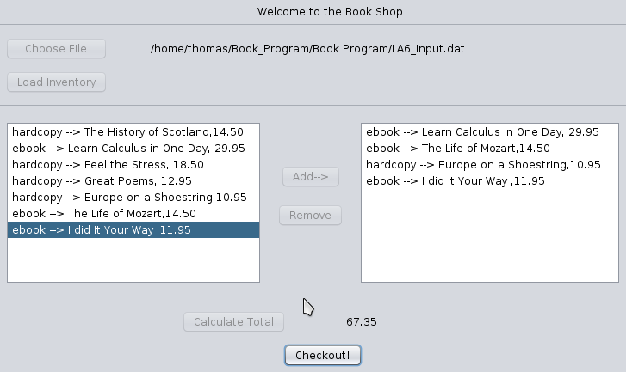

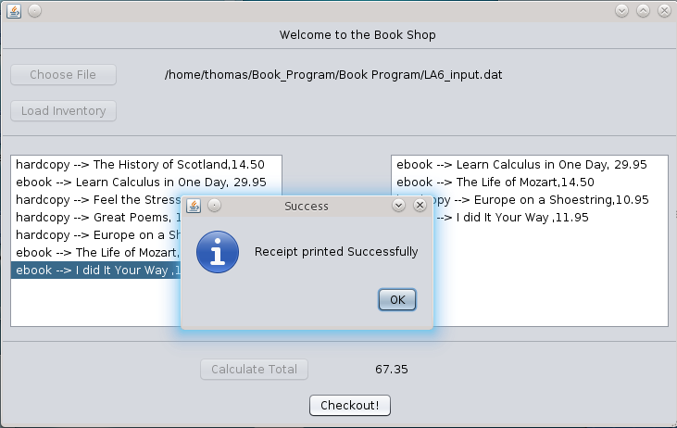

I verified that this output satisfies program requirements.

PHASE 7: REFINING THE PROGRAM (“Add bells and whistles to the program”)
No refinements are needed. In this program, I have already included all required features. But, a logging applet was made to assist in creating the Pair Programming log

PHASE 8: PRODUCTION

I prepared a copy of the entire program for Lab TA’s evaluation, as specified by the TA.
Then, I sent electronically the copy to the Lab TA.

PHASE 9: MAINTENANCE

To fully benefit from the program evaluation feedback received from the Lab TA, I will perform program maintenance. This means that I should use all TAs feedback to improve my program.

